Page 1

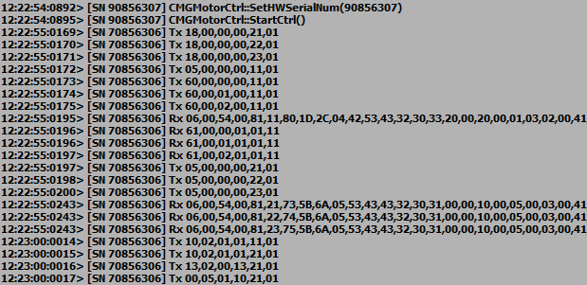

MGMSG_HW_NO_FLASH_PROGRAMMING 0x0018 (page 35)

Function: This message is sent on start up to notify the controller of the source and destination addresses. A client application must send this message as part of its initialisation process. (This is shown for a BSC203 – 3 channel controller)

MGMSG_HW_REQ_INFO 0x0005 (page 26)

Sent to request hardware information from the controller.

MGMSG_RACK_REQ_BAYUSED 0x0060 (page 28)  
Sent to determine whether the specified bay in the controller is occupied.  
Rx lines are the responses from the controller

MGMSG_HW_REQ_INFO 0x0005 (page 26)  
MGMSG_HW_GET_INFO 0x0006 (page 26)  
Another hardware request to each channel bay is sent and responses returned

MGMSG_MOD_SET_CHANENABLESTATE 0x0210 (page 21)  
Sent to enable or disable the specified drive channel.

MGMSG_MOD_SET_DIGOUTPUTS 0x0213 (page 32)  
The CONTROL IO connector on the rear panel of the unit exposes a number of digital outputs. The number of outputs available depends on the type of unit. This message is used to configure these digital outputs.

MGMSG_MOT_SET_TRIGGER 0x0500 (page 102)  
This message is used to configure the Motor controller for triggered move operation.

Continued…

MGMSG_MOT_SET_VELPARAMS 0x0413 (page 39)  
Used to set the trapezoidal velocity parameters for the specified motor channel.

Page 2

MGMSG_MOT_SET_JOGPARAMS 0x0416 (page 41)  
Used to set the velocity jog parameters for the specified motor channel,

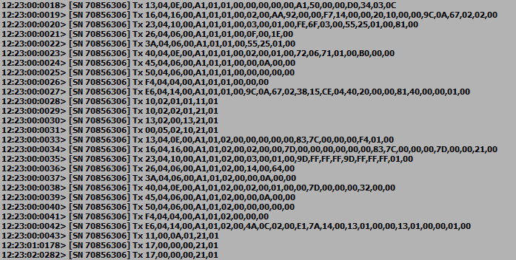

MGMSG_HW_START_UPDATEMSGS 0x0011 (see page 25)  
Sent to start status updates from the embedded controller.

This section is a repeat of the last section, I am not clear why this is happens.

MGMSG_MOT_SET_PMDJOYSTICKPARAMS 0x04E6 (see page 86)

MGMSG_MOT_SET_BOWINDEX 0x04F4 (see page 63)

MGMSG_MOT_SET_MOVERELPARAMS 0x0445 (see page 47)

MGMSG_MOT_SET_MOVEABSPARAMS 0x0450 (see page 48)

MGMSG_MOT_SET_HOMEPARAMS 0x0440 (see page 49)

MGMSG_MOT_SET_GENMOVEPARAMS 0x043A (see page 46)

MGMSG_MOT_SET_POWERPARAMS 0x0426 (see page 44)

MGMSG_MOT_SET_LIMSWITCHPARAMS 0x0423 (page 51)  
Used to set the limit switch parameters for the specified motor channel.